Cloud Computing

**Name:** Jerusha Angel K

**Register No**: 727721EUCS049

Day-4

**Day 4_IAM_CE1**

**Content Description:**

Create an IAM group called as ‘S3-Admins’ with ‘AmazonS3FullAccess’.

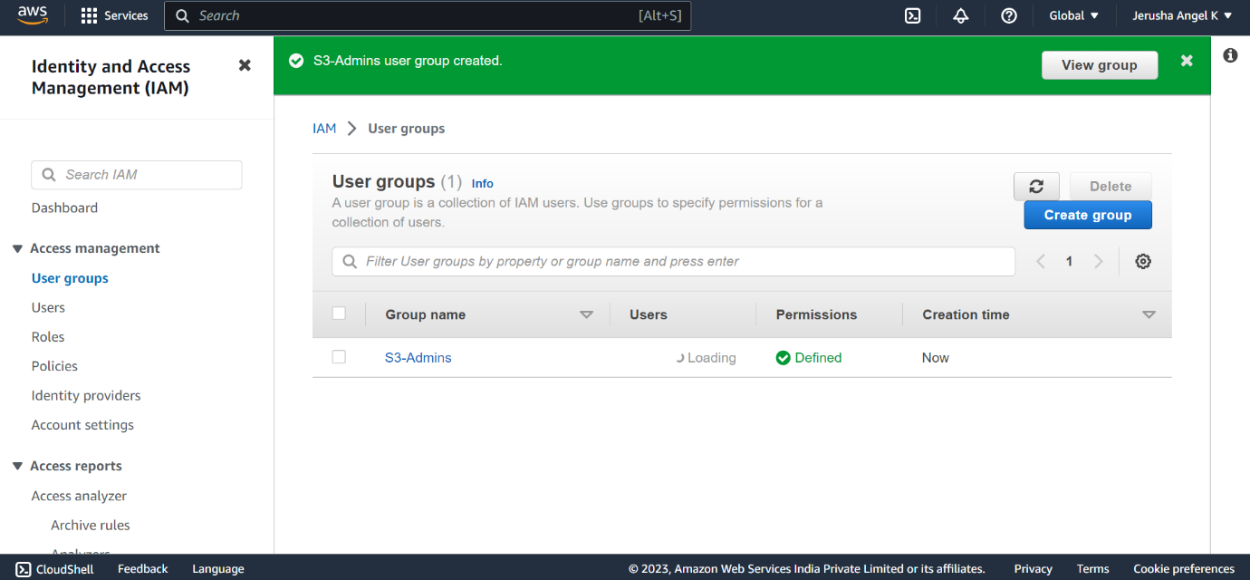

**Day 4_IAM_CE2**

**Content Description:**

Create an IAM user called as ‘S3Admin1’ and add it to the ‘S3-Admins’ group.

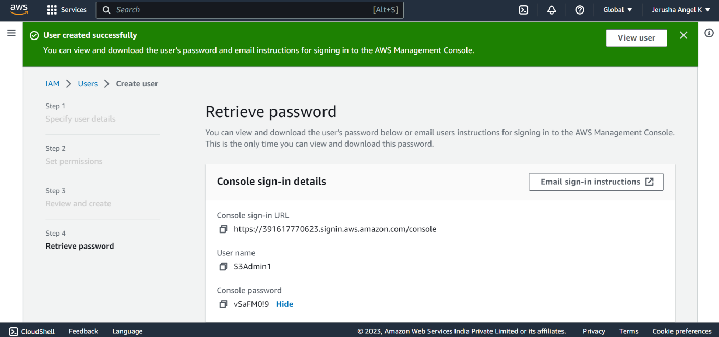

**Day 4_IAM_CE3**

**Content Description:**

Attach an IAM custom policy to the ‘S3-Admins’ group which should deny to delete objects.

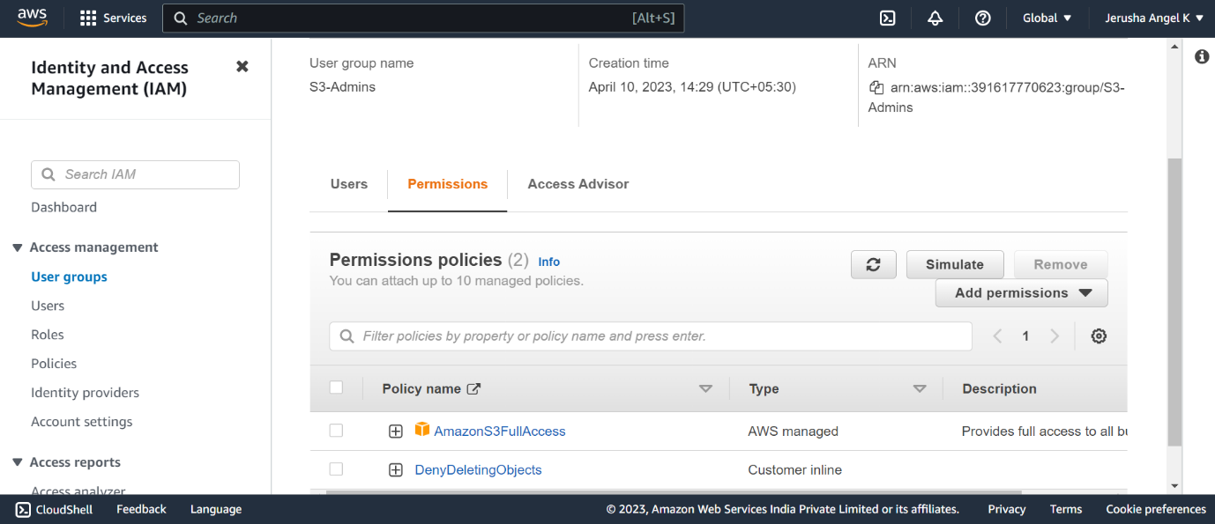

**Day 4_IAM_CE4**

**Content Description:**

Create an Inline policy for an IAM user and set some permission boundary for that user.

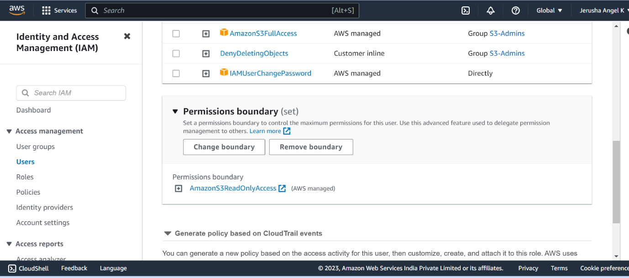

**Day 4_IAM_CE5**

**Content Description:**

Create an IAM role with ‘AmazonS3FullAccess’ and attach the role to an EC2 instance.

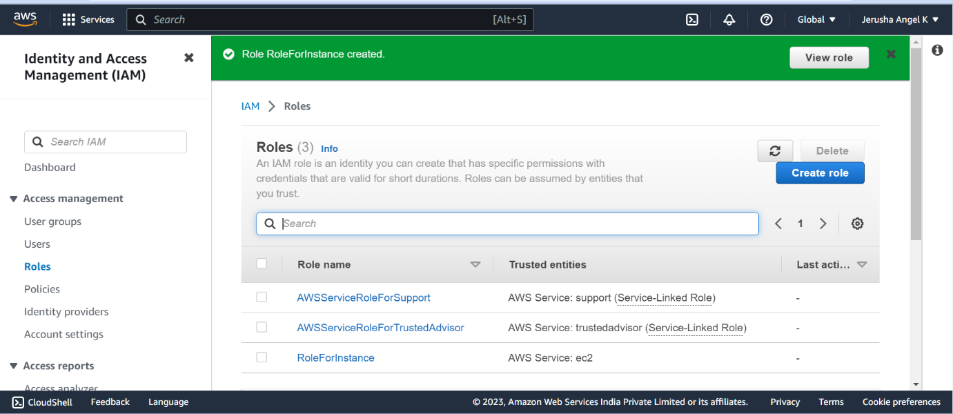

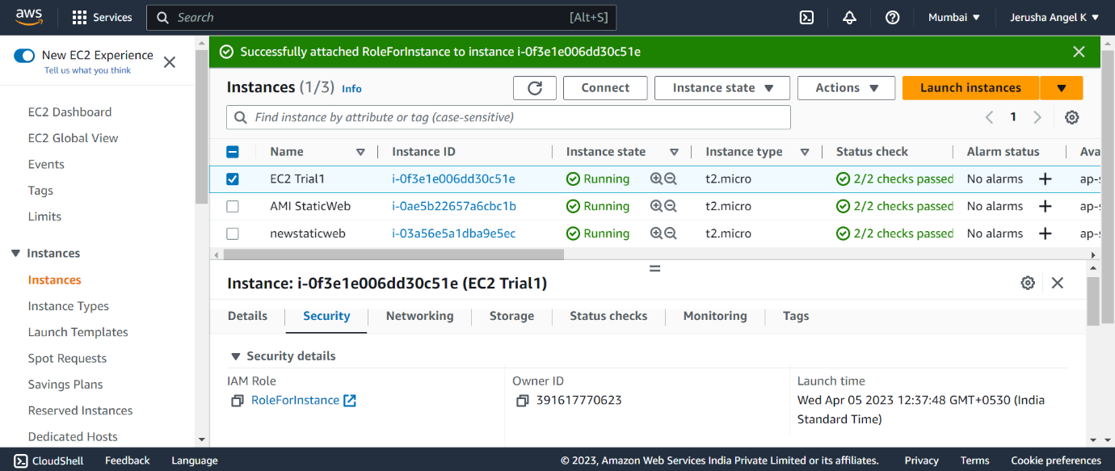

**Day 4_IAM_CE6**

**Content Description:**

Activate MFA for an IAM user and Set some Password Policies such as 1 uppercase, 1 lowercase etc

